
http://iring.ids-adi.org

Installation Guide
Version 1.01.00
Revision History
Document Version # | Action Taken, Notes | Date | Name
1.1 | First revision | 16 September 2009 | Rob DeCarlo

Terms of License
Copyright (c) 2009, ids-adi.org
All rights reserved.

Redistribution and use in source and binary forms, with or without
modification, are permitted provided that the following conditions are met:
* Redistributions of source code must retain the above copyright
notice, this list of conditions and the following disclaimer.
* Redistributions in binary form must reproduce the above copyright
notice, this list of conditions and the following disclaimer in the
documentation and/or other materials provided with the distribution.
* Neither the name of the ids-adi.org nor the
names of its contributors may be used to endorse or promote products
derived from this software without specific prior written permission.

THIS DOCUMENT IS PROVIDED BY ids-adi.org ''AS IS'' AND ANY
EXPRESS OR IMPLIED WARRANTIES, INCLUDING, BUT NOT LIMITED TO, THE IMPLIED
WARRANTIES OF MERCHANTABILITY AND FITNESS FOR A PARTICULAR PURPOSE ARE
DISCLAIMED. IN NO EVENT SHALL ids-adi.org BE LIABLE FOR ANY
DIRECT, INDIRECT, INCIDENTAL, SPECIAL, EXEMPLARY, OR CONSEQUENTIAL DAMAGES
(INCLUDING, BUT NOT LIMITED TO, PROCUREMENT OF SUBSTITUTE GOODS OR SERVICES;
LOSS OF USE, DATA, OR PROFITS; OR BUSINESS INTERRUPTION) HOWEVER CAUSED AND
ON ANY THEORY OF LIABILITY, WHETHER IN CONTRACT, STRICT LIABILITY, OR TORT
(INCLUDING NEGLIGENCE OR OTHERWISE) ARISING IN ANY WAY OUT OF THE USE OF THIS
SOFTWARE, EVEN IF ADVISED OF THE POSSIBILITY OF SUCH DAMAGE.

Table of Contents
Installation Guide 1
1.0 Overview 3
1.1 Packages 3
1.2 Package Dependencies 4
1.3 Prerequisites 5
1.4 Preparing to Install 6
2.0 Installing Prerequisites 7
2.1 .NET Framework 7
2.2 Internet Information Services 9
2.3 Java for Windows (Sandbox Only) 12
2.4 MySQL Server (Sandbox Only) 14
2.4.1 MySQL Server Installation 14
2.4.2 MySQL Server Instance Configuration 17
2.5 SQL Server 2005 (Adapter Only) 23
2.6 ADO.NET Entity Framework Provider (Adapter Only) 24
3.0 Installing iRING Sandbox 25
3.1 iRING Sandbox Components 25
3.2 Creating Virtual Directories 25
3.3 Configuring Sandbox Service 25
3.4 Testing Sandbox Service 25
3.5 Configuring Reference Data Service 25
3.6 Testing Reference Data Service 26
3.7 Configuring Reference Data Editor 26
3.8 Testing Reference Data Editor 26
4.0 Installing iRING Adapter 27

Overview
iRING is a technical reference implementation of the full specification of ISO 15926 for converting legacy data to and from an ISO 15926 representation. This guide will walk the reader through the setup of iRING. Once iRING is setup, it will still need to be configured. For this information, please see the iRING Users Guide.

Packages
iRING is deployed in two packages, iRING Adapter and iRING Sandbox. These packages are separated for deployment purposes. This allows implementers to only download and install the necessary components. The iRING Adapter is used to map and transform legacy data to ISO 15926 representation. The iRING Sandbox is used to host Reference Data of local interest or extend the reference data hosted in the RDSWIP (http://rdswip.ids-adi.org/presentation/overview/index.html) for use with the iRING Adapter. The iRING Adapter will use reference data from configured Sandboxes, as well as the RDSWIP.

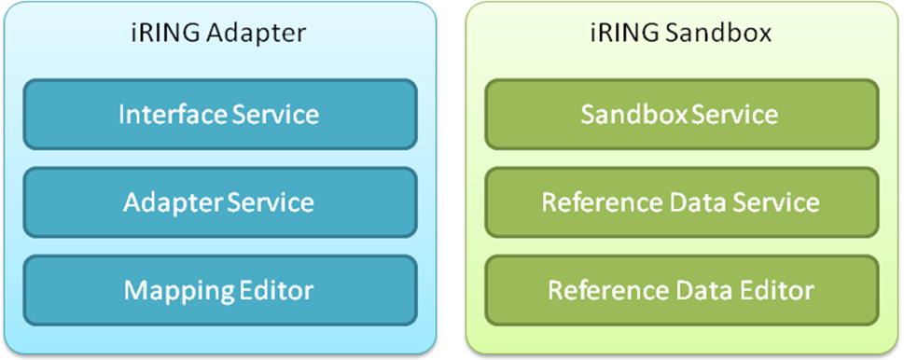

These packages do not necessarily require the other to run. The reader will need to determine which packages will need to be installed, and where they will be installed. For test purposes it is recommended that both packages be installed on a single machine. Virtual machines can be used to host iRING, but it is not required.

Package Dependencies
Though the packages are mostly independent, the iRING Adapter technically needs to access an iRING Sandbox somewhere.
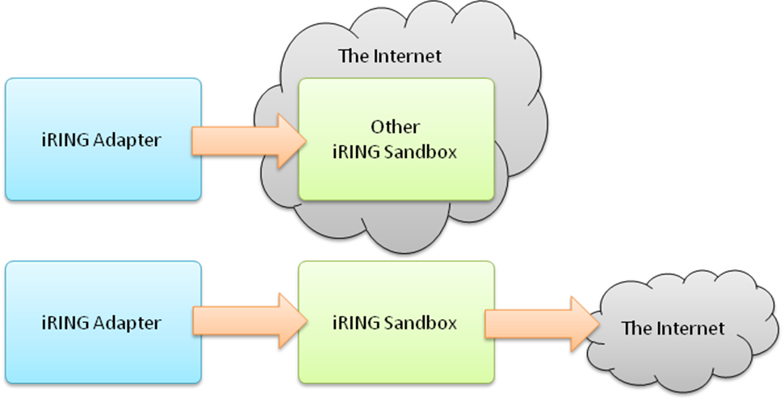
If only the iRING Adapter will be deployed, then it will require internet access to connect to an existing iRING Sandbox (e.g. IDS-ADI Community Sandbox). If both packages will be deployed, it is assumed that the iRING Adapter will use the reference data in the iRING Sandbox. In this case, the iRING Adapter will connect directly to the iRING Sandbox being deployed (e.g. Private Sandbox). The iRING Sandbox will require internet access to connect to the RDSWIP.

Prerequisites
There are several prerequisites and assumptions that are made in this guide. Some instructions are provided for setting up and configuring the prerequisites, but the instructions may not handle every case. Please see the documentation links provided in the section for each prerequisite for more information.
The base assumptions made by this guide are:
- That the host server is running Windows Server 2003 SP1.
- That the installer has administrative access to the host server.
- That the installer will be able to login to the graphical user interface on the host server.
- That the installer has basic knowledge of the Windows Operating System and Windows Security.
Older and newer versions of windows are supported, but installation and configuration may be different in those cases. No instructions will be given to guide the reader to properly secure the operating system or the files on the host server. However, instructions will be provided on how to use the specific features of the operating system that are required to properly configure iRING.
There are several significant software components that are required by iRING. These prerequisites are:
- .NET Framework 3.5 SP1
- Internet Information Services 6.0
- Java for Windows Version 6 Update 16 or higher (aka Java SE Runtime Environment 1.6.0_16)
- MySQL Server 5.1 or higher
- ADO.NET Entity Framework Provider and appropriate client software for accessing your legacy application database (Adapter Only)
It is recommended that the reader understand these prerequisites and how they work before attempting to install iRING. However, instructions will be provided for how to use the specific features of these systems to properly configure iRING.
Finally, iRING is built on top of other Semantic Web technologies. These technologies include:

- Jena - A Semantic Web Framework for Java (http://jena.sourceforge.net/)
- Joseki - A SPARQL Server for Jena (http://www.joseki.org/)
It is recommended that the reader simply be aware that these technologies are being used. The guide will provide all the instructions necessary, and in most cases the configuration and use of these technologies is being fully automated.

Preparing to Install
Before beginning the installation, the reader should decide which iRING packages will be required. This will determine which prerequisites will need to be installed. Once the prerequisites are installed, the appropriate packages should be downloaded from the iRING web site:
- iRING Downloads - http://iring.codeplex.com/Release/ProjectReleases.aspx
Next, unzip the package(s) to a folder on the target machine called iRINGWeb, such that the folders in the ZIP file(s) will appear as subfolders of iRINGWeb. When unzipping, the Tools folders can be safely merged.
There are other software packages that may be required. Installation links will be provided in the detailed sections, as they are not always required.
iRING is a web-enabled system, and therefore requires access to the internet to work properly. If the host server is behind a firewall, the proxy server information and valid proxy credentials will be needed to be entered into the configuration later.
Further, the iRING Sandbox will be federating Reference Data from the RDSWIP
(http://rdswip.ids-adi.org/presentation/overview/index.html), and generating Identifiers for Reference Data. Therefore, an identity from ids-adi.org will need to be obtained. Those credentials will be needed to be entered into the configuration later.
If there are any existing iRING Sandboxes that will be used by the iRING Adapter being deployed, then the URLs and any required credentials for those iRING Sandboxes will need to be entered into the configuration later.

Installing Prerequisites
The following sections will provide detailed instructions for the installation and configuration of each of the prerequisites.

.NET Framework
The .NET Framework is used by most of the iRING components. The latest .NET Framework is version 3.5 SP1. Specifically, this version includes the Entity Framework which is used by iRING as the default DataLayer. To install the .NET Framework, perform the following:

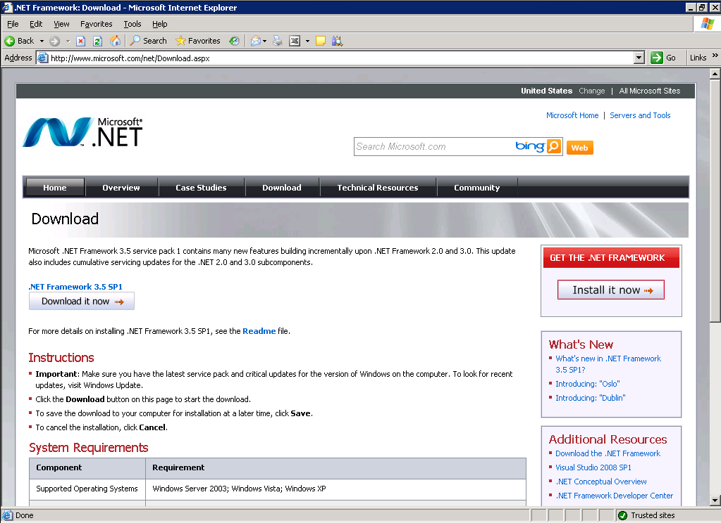

- Download and install .NET Framework 3.5 SP1 from http://www.microsoft.com/net/Download.aspx.
- From a command prompt, type %systemroot%\Microsoft.NET\Framework\v3.5\csc and verify the installed version.
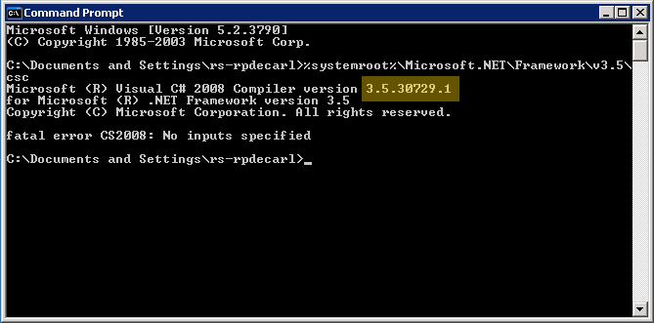

Internet Information Services
IIS is technically part of the Windows Server 2003 operating system. However, it is an optional component, and is typically not installed by default. To check that IIS is installed and, if necessary, install it perform the following:
- From the Start menu, click Control Panel.
- Double-click Add or Remove Programs.
- Click Add/Remove Windows Components.
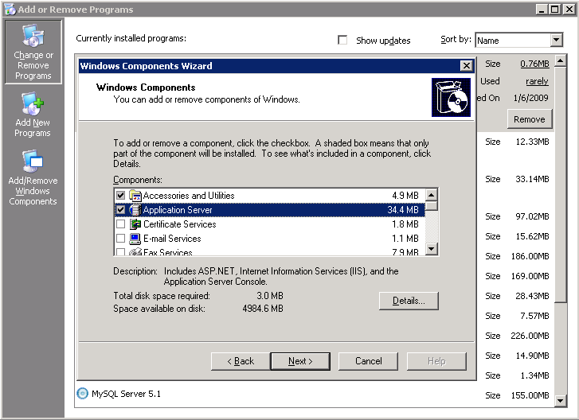
- In the Components list box, click Application Server.
- Click Details.
- Click Internet Information Services (IIS).
- Click Details to view the list of IIS Subcomponents.
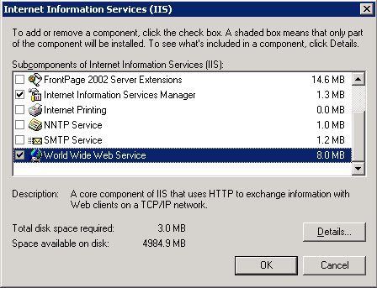
- Ensure that the Common Files (not shown), Internet Information Services Manager and World Wide Web Service are checked.
- Click World Wide Web Service.
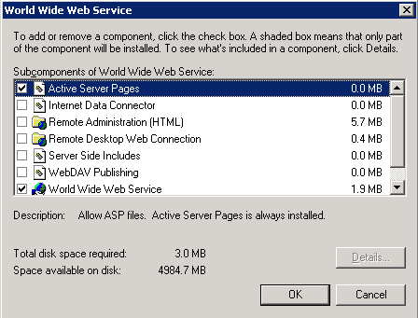
- Ensure that Active Server Pages and World Wide Web Service are checked.
- Click OK until you are returned to the Windows Component Wizard.
- Click Next and complete the Windows Component Wizard.
IIS combines and exposes many different technologies, and it can be a challenge to deploy. Certain subcomponents of IIS may not have been installed in the expected order. Further, installing IIS after applying a Service Pack can lead to other subcomponents becoming unregistered. For this reason, the following steps are not always required, but may help if IIS is not functioning properly. Links have been provided to Microsoft websites that give detailed instructions on how to resolve these common issues.
- Ensure that ASP.NET is installed (http://www.microsoft.com/technet/prodtechnol/WindowsServer2003/Library/IIS/01563a60-038c-46d8-9a63-5104f5816767.mspx?mfr=true)
- Ensure that Dynamic Content is enabled (http://www.microsoft.com/technet/prodtechnol/WindowsServer2003/Library/IIS/a9fc0395-f03b-4213-9c62-1592bcfcf53f.mspx?mfr=true)
- Ensure that ASP.NET 2.0 is registered (only do if necessary) (http://msdn.microsoft.com/en-us/library/k6h9cz8h(VS.80).aspx)

Java for Windows
Java for Windows, or the Java SE Runtime Environment, is used by the Sandbox Service in the iRING Sandbox package. To install Java for Windows perform the following:

- Download and run the installer for Java for Windows Version 6 Update 16 or greater located at http://www.java.com/en/.

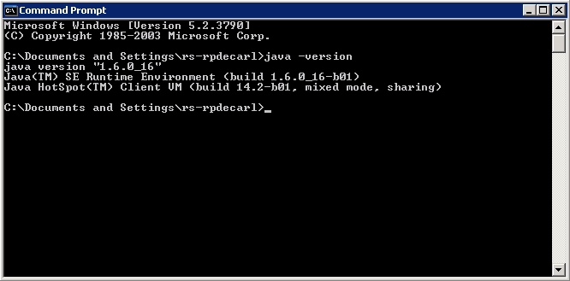

- From a command prompt, type java –version and verify the installed version.

Trouble Shooting Tip
If the version does not reflect the version downloaded, ensure that another version of Java was not previously installed in another location, which can include ORACLE databases. The PATH environment variable, which is used for many different things, also contains all paths for Java that have been installed. From the command prompt, type set | findstr /i "^path=" to review the PATH environment variable. Ensure that the bin directory in the path that Java was just installed into appears first in the environment variable.

MySQL Server
MySQL is the physical database where the Sandbox Service will store the reference data as triples. The setup process has two stages, installation and instance configuration. The installer will automatically launch the configuration tool. This guide will provide detailed instructions for both stages.
This guide will only provide instructions for installing the MySQL Community Server 5.1. The MySQL GUI Tools provide management and query tools, and they can be downloaded from http://dev.mysql.com/downloads/gui-tools/5.0.html. These tools are optional and are not required for installation. For documentation of the GUI tools or if your deployment deviates from this guide, see http://dev.mysql.com/doc/.

MySQL Server Installation
To install the MySQL database, run the MSI installer and complete the following steps:
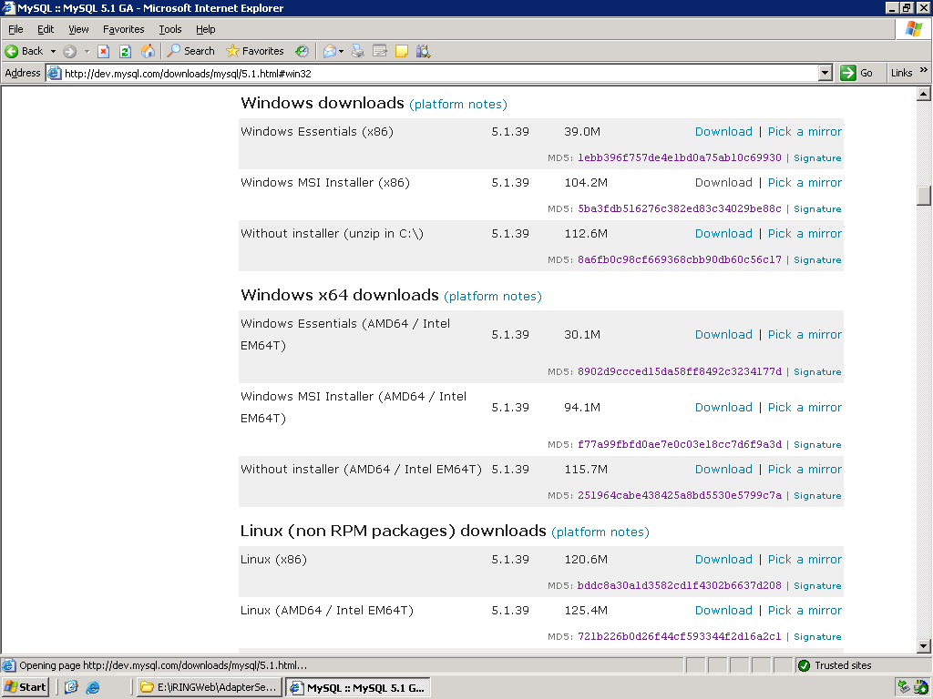
- Download and run the MSI installer for MySQL Community Server 5.1 or greater located at http://dev.mysql.com/downloads/mysql/5.1.html#win32.

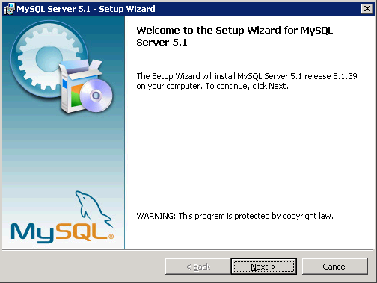
- On the welcome screen click Next.
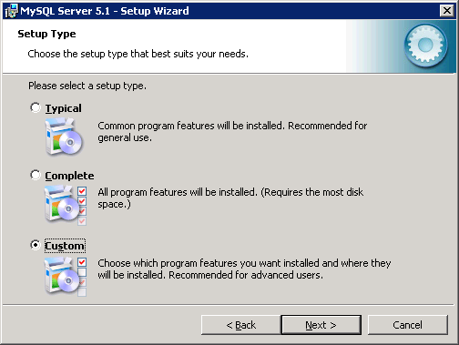
- The typical settings will be the basis of the Custom setup type, but the installer will have the opportunity to change each setting along the way. Select the Custom setup type and click Next.
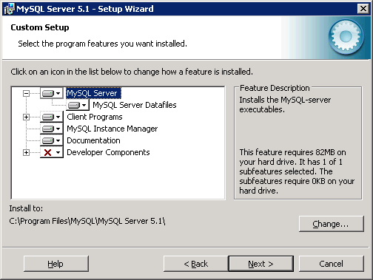
- The Custom Setup screen gives the installer the opportunity to change the default paths for where the software components and data files will be installed. This is required in most enterprise environments. The locations that you should choose will likely be determined by your server standards. If your environment does not have any such standards, the defaults are recommended.
  - Click on MySQL Server and verify the Install To: location.
  - Click Change to change the location if necessary.
  - Click on MySQL Server Datafiles and verify the Install To: location.
  - Click Change to change the location if necessary.
  - Click Next to continue.

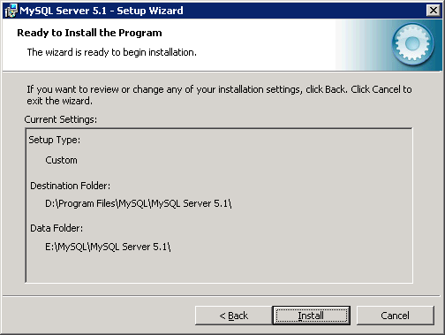
- On the Ready to Install the Program screen, review your settings and click Install.
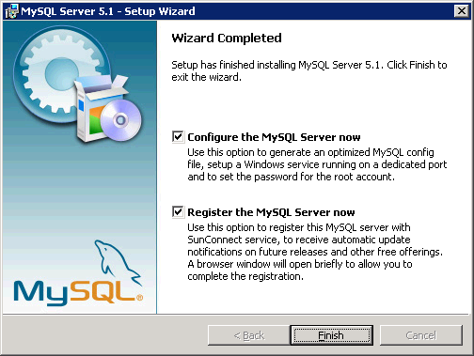
- When the installation is complete, the Wizard Complete screen will appear. There are two options on this screen. This guide will not cover registering the MySQL Server you just installed. To complete the install and begin the configuration:
  - Ensure that Configure the MySQL Server now is checked.
  - Click Finish to launch the Instance Configuration Wizard.

MySQL Server Instance Configuration
The installation should have launched the configuration tool. To configure the MySQL Server instance, complete the following steps:
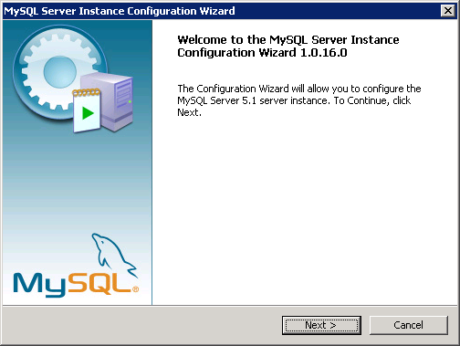
- On the welcome screen click Next.
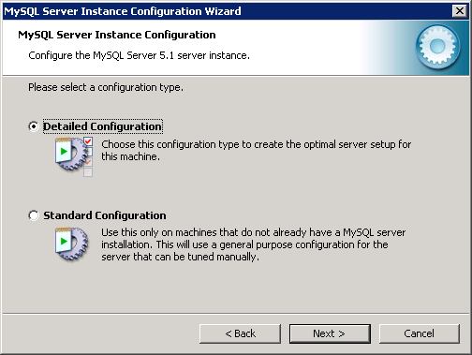
- The standard configuration will work for the Sandbox Service, but it is recommended that the default configuration be performed, as some of the recommended settings to follow may become more important as the scale of data increases. Select the Detailed Configuration type and click Next.

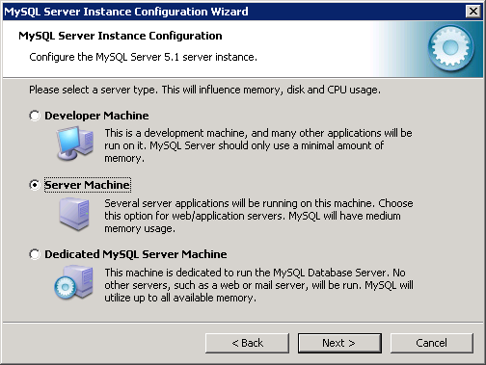
- Choose the appropriate selection for the host environment and click Next.
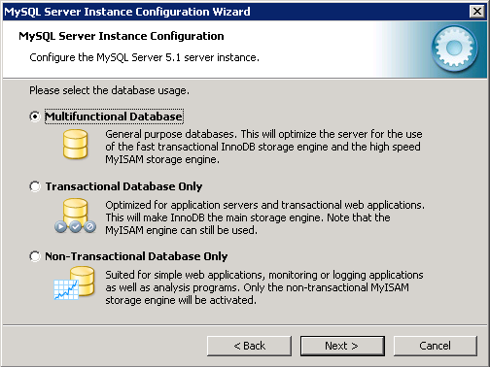
- The default selection of Multifunctional Database will work for iRING, click Next.
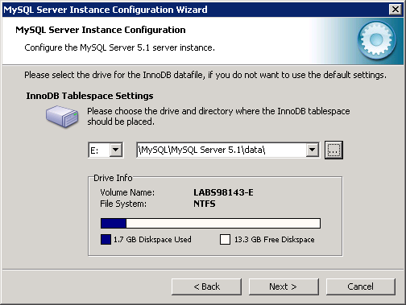
- Ensure that the InnoDB datafile will be created where the instance datafiles were created during the installation. Note, that the Installation Path choice does not do this.
- Click Next to continue.
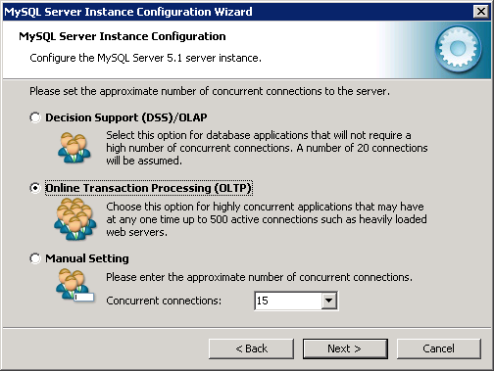
- Since there could be many concurrent connections to enable federated search and improve performance, select Online Transaction Processing (OLTP) and click Next.
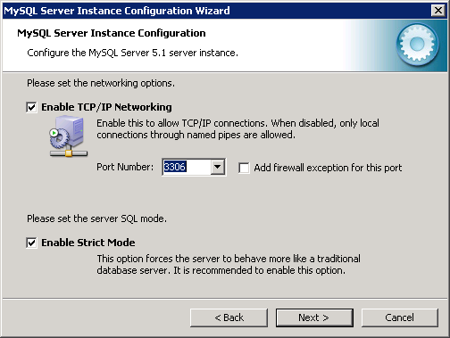
- For most environments, the default networking options will work fine.
  - If you need to adjust the Port Number, select or enter the desired Port Number.
  - Click Next to continue.
WARNING: The installer cannot handle certain situations if the Add firewall exception for this port option is checked. This guide recommends adding any firewall rules manually with the operation system provided utilities.

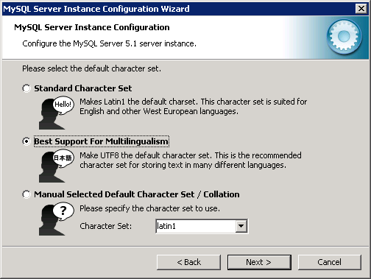
- Select Best Support for Multilingualism and click Next.
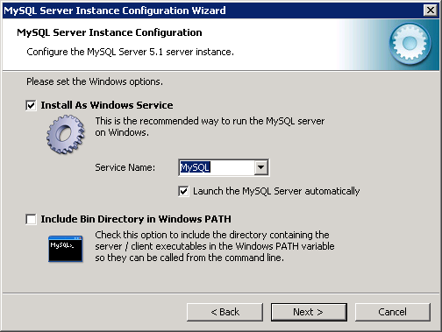
- The defaults are recommended for this screen. Click Next to continue.
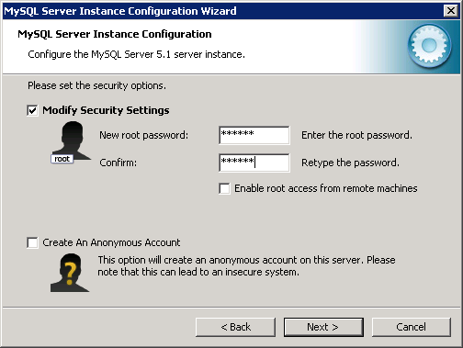
- Enter and confirm a password for the root user account (this is the system administrator).
- Click Next to continue.
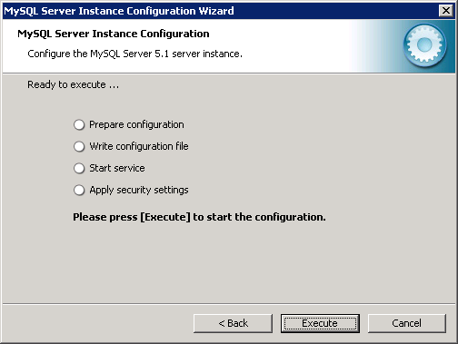
- On the Ready to execute screen, click Execute.
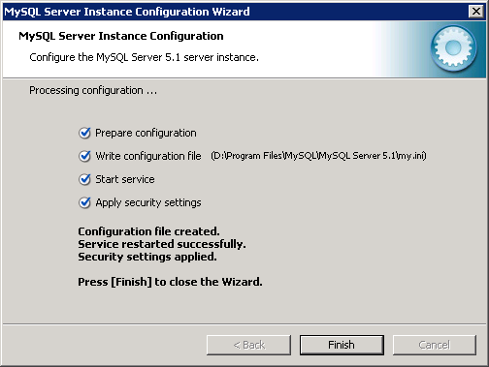
- When the configuration processing is completed, click Finish to complete the configuration of the MySQL Server instance.

SQL Server 2005 (Adapter Only)
To be completed.

http://www.microsoft.com/downloads/details.aspx?familyid=7522A683-4CB2-454E-B908-E805E9BD4E28&displaylang=en

ADO.NET Entity Framework Provider (Adapter Only)
To be completed.

Installing iRING Sandbox
The following sections will review the iRING Sandbox components and provide detailed instructions on how to install and configure each component.

iRING Sandbox Components
The iRING Sandbox is comprised of three components; Sandbox Service, Reference Data Service and Reference Data Editor. These components interact with each other, as well as the internet to manage the Reference Data contained in the iRING Sandbox and provide federated search functionality.

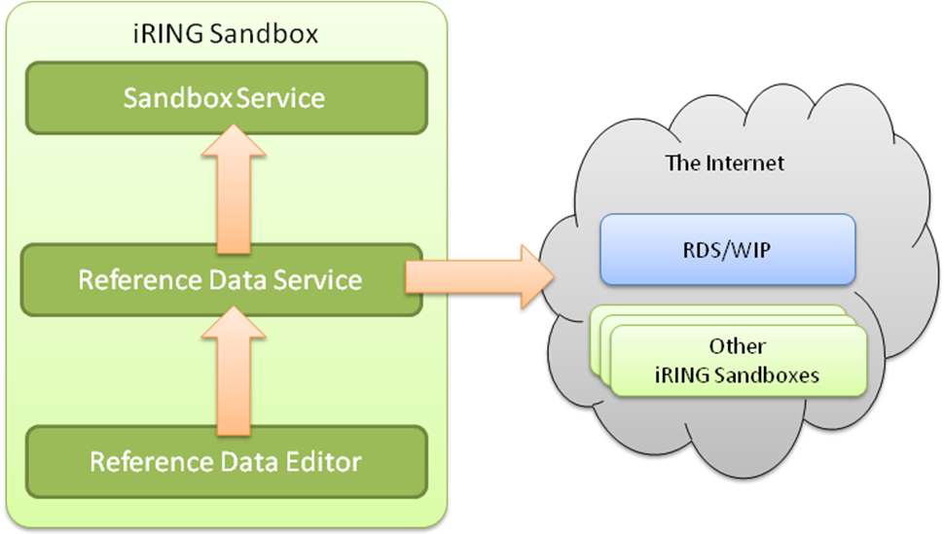
The Sandbox Service encapsulates the physical triple store, and provides SPARQL Query and Update functionality. The Reference Data Service forms the core of the iRING Sandbox, and provides a web service API for performing federated searches across RDSWIP and other configured Sandboxes. The web service API also provides CRUD (Create, Read, Update and Delete) operations on the reference data stored within the Sandbox Service. In this way, the Reference Data Service depends on the Sandbox Service as well as access to the internet. The Reference Data Editor provides a graphical user interface for searching, navigating, and managing (CRUD) reference data. It uses the Reference Data Service for all of its functionality.

Sandbox Service Setup

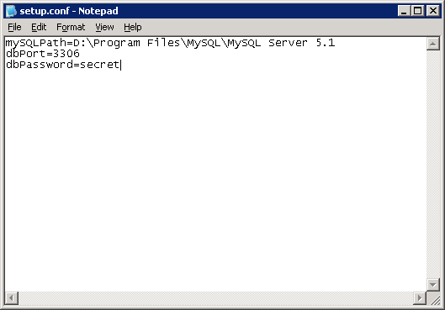

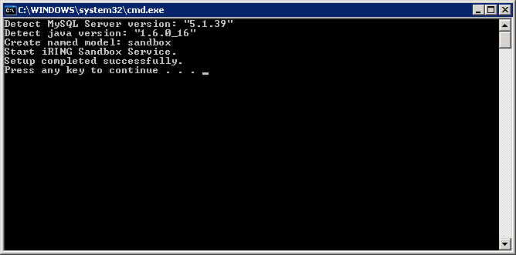

Testing Sandbox Service

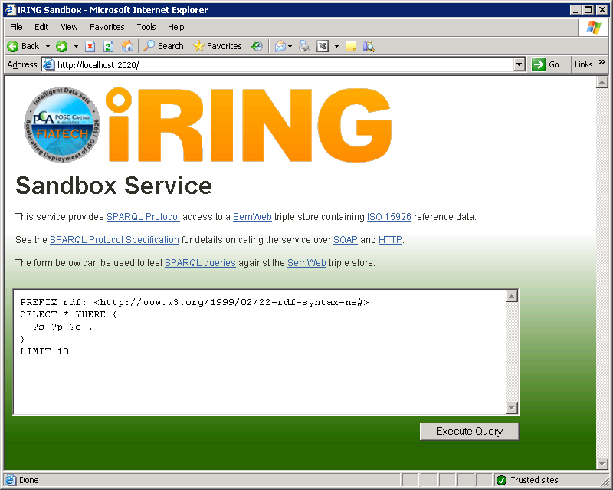

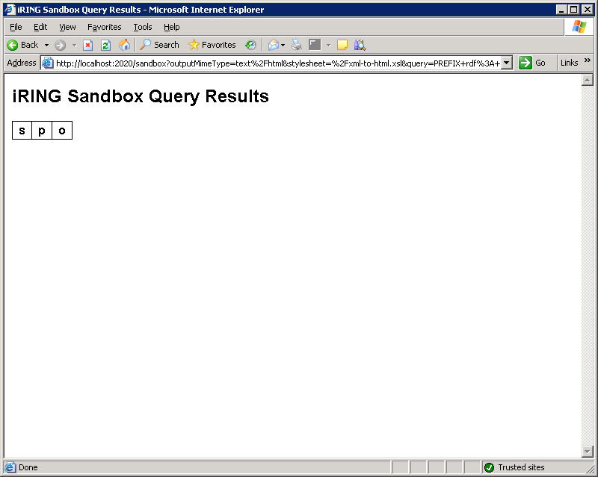

Creating Virtual Directories
The remaining components in the iRING Sandbox are all web applications that will need to be setup and configured in IIS.
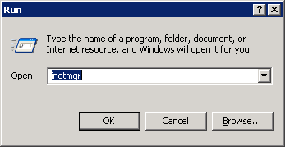

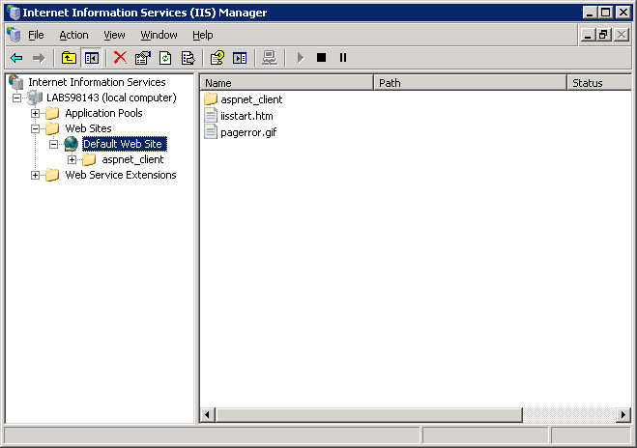
Action -> New -> Virtual Directory…

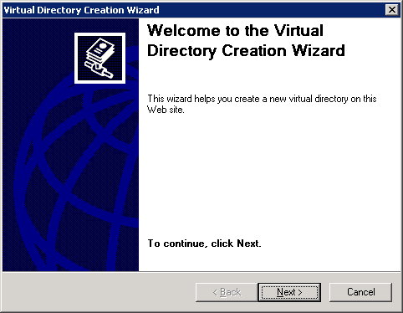

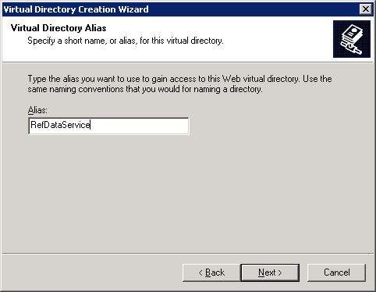
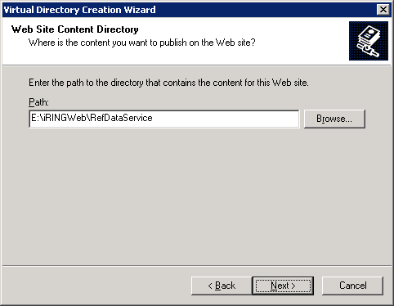

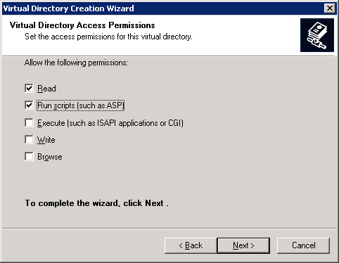

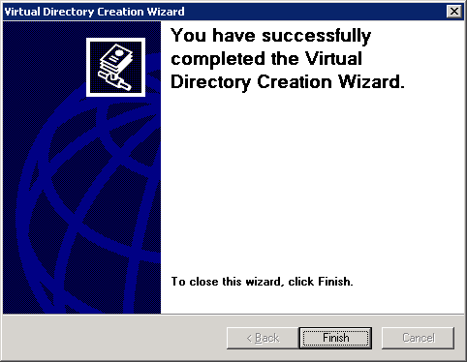

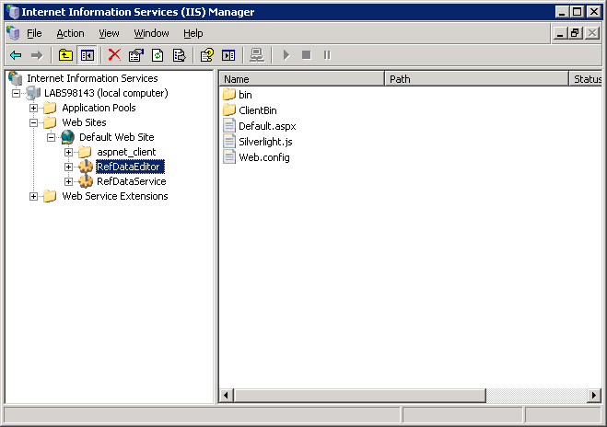

Configuring Reference Data Service
Dslfsfposidfdsflkds

Creating Credential Tokens
Djfldskfjdslkfjlksjdf

Modifying the Web.config
- RegistryCredentialToken – Credential token of a valid ids-adi account.
- ProxyCredentialToken - Credential token for ReferenceDataService proxy server.
- ProxyHost - ReferenceDataService proxy server name.
- ProxyPort - ReferenceDataService proxy port number.
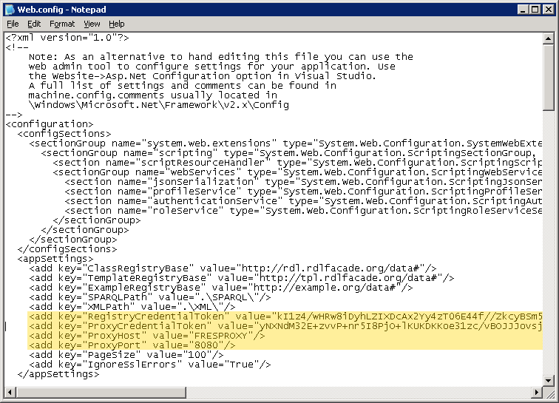

Testing Reference Data Service
(http://localhost/RefDataService/Service.svc)

Configuring Reference Data Editor

Modifying the Web.config
- ReferenceDataServiceUri - Base URI of the ReferenceDataService.

Testing Reference Data Editor
http://localhost/RefDataEditor/Default.aspx

Installing iRING Adapter

iRING Adapter Components

Creating Virtual Directories
The remaining components in the iRING Adapter are all web applications that will need to be setup and configured in IIS.

Action -> New -> Virtual Directory…

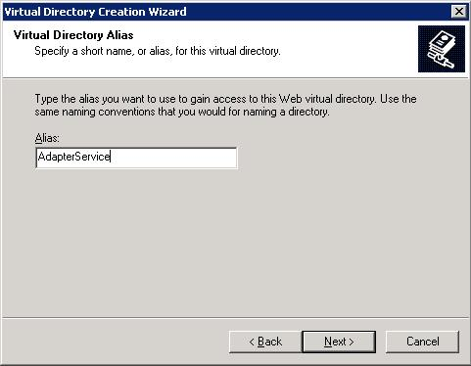
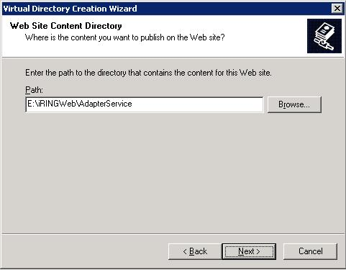

TODO : Add final screen here.

Configuring Interface Service

Testing Interface Service

Configuring Adapter Service

Modifying the Web.config
- TripleStoreConnectionString–
Create a triple store by using following command line:
iRING triple store creation command line
rdfstorage.exe -clear -out "sqlserver:rdf:Database=rdf;data source=[Server Name]; Initial Catalog=iRING; User Id=iRING; Password=iRING;"
and then enter the value of triple store connection string as below:
sqlserver:rdf:Database=rdf;data source=[Server]; Initial Catalog=[Database]; User Id=[User Id]; Password=[Password];
- Entities connection string – Enter the connection string of legacy database as below:
metadata=|DataDirectory|\Model.csdl| |DataDirectory|\Model.ssdl| |DataDirectory|\Model.msl; provider=System.Data.SqlClient; provider connection string=&quot;data source=[Server]; Initial Catalog=[Database]; User Id=[User Id]; Password=[Password];&quot;
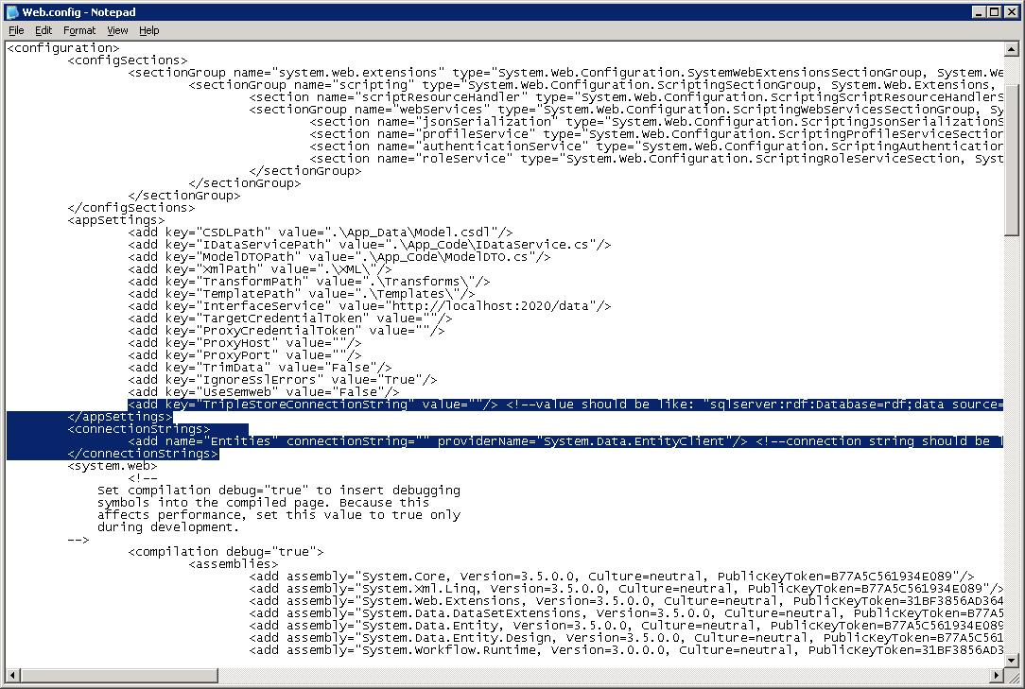

Testing Adapter Service
http://localhost/AdapterService/Service.svc

Configuring Mapping Editor

Modifying the Web.config
- AdapterServiceUri- Base URI of the AdapterService.
- ReferenceDataServiceUri - Base URI of the ReferenceDataService.

Testing Mapping Editor
http://localhost/MappingEditor/Default.aspx

Create two triple store databases in SQL Server – Sandbox and iRING by executing rdfstorage.exe located under Tools using following command line-
Sandbox triple store creation command line
rdfstorage.exe -clear -out "sqlserver:rdf:Database=rdf;data source=[Server Name]; Initial Catalog=sandbox; User Id=sandbox; Password=sandbox;"
iRING triple store creation command line
rdfstorage.exe -clear -out "sqlserver:rdf:Database=rdf;data source=[Server Name]; Initial Catalog=iRING; User Id=iRING; Password=iRING;"
- Create iRINGWeb folder on appropriate drive on the server.
- Copy iRINGAdapter and iRINGSandbox folders into the iRINGWeb folder.
- Create an application for iRINGAdapter subfolders – AdapterService, InterfaceService and MappingEditor and iRINGSandbox subfolders – RefDataEditor, RefDataService and SandboxService from IIS Manager.
  - Select Read and Execute permission.
  - For MappingEditor and RefDataEditor, add "application/x-silverlight-app" MIME Type for .xap file extension.
- Edit AppSettings/ConnectionStrings/SparqlResources in each Web.config.
  - AdapterService (http://localhost/AdapterService/Service.svc)
    - CSDLPath - Path of your CSDL file.
    - TargetCredentialToken – Credential token for target server. Blank in this case.
    - ProxyCredentialToken - Credential token for AdapterService proxy server.
    - ProxyHost - AdapterService proxy server name.
    - ProxyPort - AdapterService proxy port number.
    - TripleStoreConnectionString
    - connectionStrings\add where name="Entities"
(under ConnectionStrings.) - This is the Entity Framework connection string. It contains the ADO.NET connection string for your legacy database as well as the location of Entity Framework artifacts, including CSDL file.
  - ReferenceDataService (http://localhost/ReferenceDataService/Service.svc)
    - RegistryCredentialToken – Credential token of a valid ids-adi account.
    - ProxyCredentialToken - Credential token for ReferenceDataService proxy server.
    - ProxyHost - ReferenceDataService proxy server name.
    - ProxyPort - ReferenceDataService proxy port number.
  - MappingEditor (http://localhost/MappingEditor/Default.aspx)
    - AdapterServiceUri- Base URI of the AdapterService.
    - AdapterProxyCredentialToken - Credential token for AdapterService proxy server.
    - AdapterProxyHost - AdapterService proxy server name.
    - AdapterProxyPort - AdapterService proxy port number.
    - ReferenceDataServiceUri - Base URI of the ReferenceDataService.
    - ReferenceDataProxyCredentialToken - Credential token for ReferenceDataService proxy server.
    - ReferenceDataProxyHost - ReferenceService proxy server name.
    - ReferenceDataProxyPort - ReferenceService proxy port number.
  - RefDataEditor (http://localhost/RefDataEditor/Default.aspx)
    - ReferenceDataServiceUri - Base URI of the ReferenceDataService.
    - ReferenceDataProxyCredentialToken - Credential token for ReferenceDataService proxy server.
    - ReferenceDataProxyHost - ReferenceService proxy server name.
    - ReferenceDataProxyPort - ReferenceService proxy port number.
  - InterfaceService (http://localhost/InterfaceService/index.html)
    - /InterfaceService/sparql- Database (iRING Triple store) connection string.
  - SandboxService (http://localhost/SandboxService/index.html)
    - /SandboxService/sparql- Database (Sandbox Triple store) connection string.

